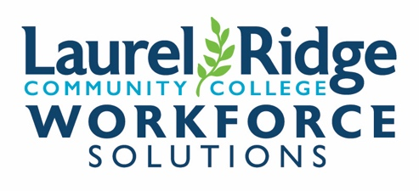
Authorization to Bill – Leadercast 2025
Thank you for your interest in Leadercast 2025 event. Payment is required at the time of registration; this form will allow us to invoice your company/organization; however, we need billing information and your authorization to do so PRIOR to registration. If you have a question, contact Corporate Training at (540) 868-7021 or corporatetraining@Laurelridge.edu
DIRECTIONS
Please complete the following form providing all requested information. Once you have completed this form, it requires an authorized signature from your company/organization. Use this form for all students in one class.
Once this form is received, we will invoice you when the class(es) begin. Terms are Net 30 from the Invoice/Statement Date and payable to Laurel Ridge Workforce Solutions. Most Invoice/Statements are typically itemized by student, class name, class dates, and amount.
FOUR OPTIONS FOR SUBMITTING AUTHORIZATION TO Workforce Solutions Continuing Education (WSCE)
- SCAN the completed and signed form, save as a PDF, and EMAIL. Email the form to our office at corporatetraining@laurelridge.edu
- MAIL the completed and signed form to WSCE at Laurel Ridge Workforce Solutions, ATTN: Corporate Training/Registration, 173 Skirmisher Lane, Middletown, VA.
- BRING the completed and signed form to either the WSCE office in Middletown (Corron Center) or Fauquier (Wok Hall).

TODAY’S DATE:
Company / Organization Information |  |  |  | Invoice/Statement to be mailed to this address
 | COMPANY/ORGANIZATION NAME:
 | ATTN: Accounts Payable or:
 | PO BOX OR STREET ADDRESS
 | CITY, STATE, ZIP
 | PHONE NUMBER
 | FAX NUMBER
 | COMPANY/ORGANIZATION FEDERAL IDENTIFICATION NUMBER (EIN or FIN)

Company/Organization Authorization:
NAME:
TITLE
PHONE:
EMAIL

Signature: Authorization to Bill must be signed.
 | AUTHORIZED SIGNATURE: |  | DATE:

Shentel Event: Friday, June 20, 2025
Hosted at the Shentel, Edinburg
Individual Event Ticket: $149 per person

Total # of Participants:

Enter participants on next page…
Participants Information:
We authorize Laurel Ridge Community College to invoice our company/organization for the following students who are taking this class:

 | Employee’s Full/Legal Name | Date of Birth | Employee’s Email Address | Employee’s Direct Phone #
1
2
3
4
5
6
7
8
9
10
11
12

